**Ex33andEx46Chp5**

**Exercise 33-Chapter 5**

A router has the following (CIDR) entries in its routing table:

**Address/mask Next hop**

135.46.56.0/22 Interface0

135.46.60.0/22 Interface 1

192.53.40.0/23 Router 1

Default Router 2

For each of the following IP addresses, what does the router do if a packet with that address arrives?

1. 135.46.63.10

It will be routed through Interface 1

1. 135.46.57.14

It will be routed through Interface 0

1. 135.46.52.2

It will be routed through Router 2

1. 192.53.40.7

It will be routed through Router 1

1. 192.53.56.7

It will be routed through Router 2

**Exercise 46-Chapter 5**

Use the traceroute (UNIX) or tracert (Windows) programs to trace the route from your computer to various universities on other continents. Make a list of transoceanic links you have discovered. Some sites to try are

Screenshots on other pages

www.berkeley.edu (California)

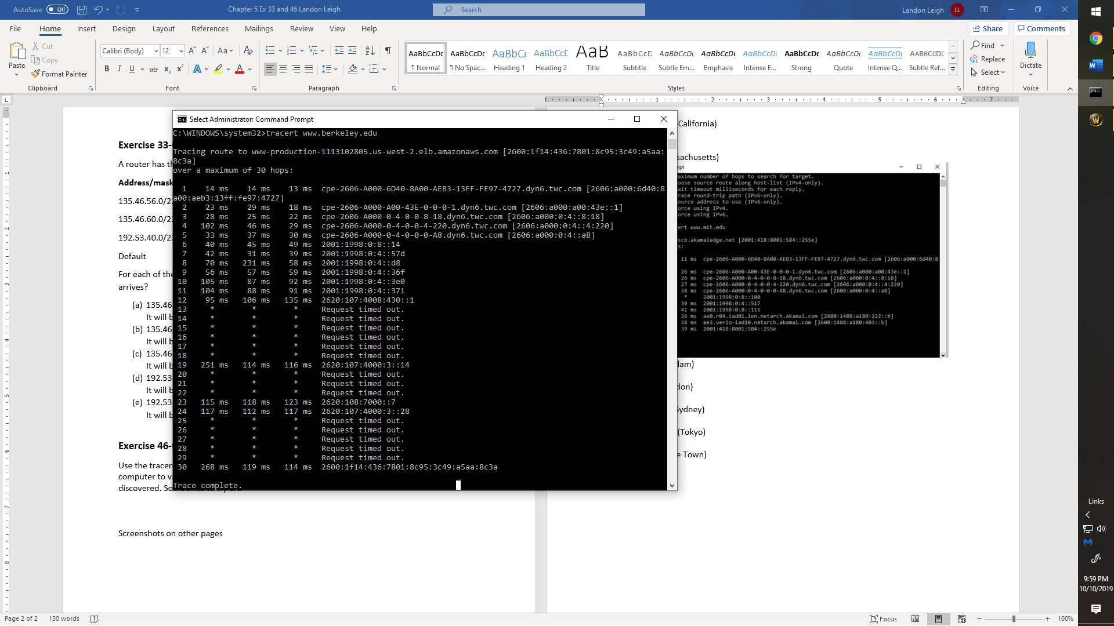

www.mit.edu (Massachusetts)

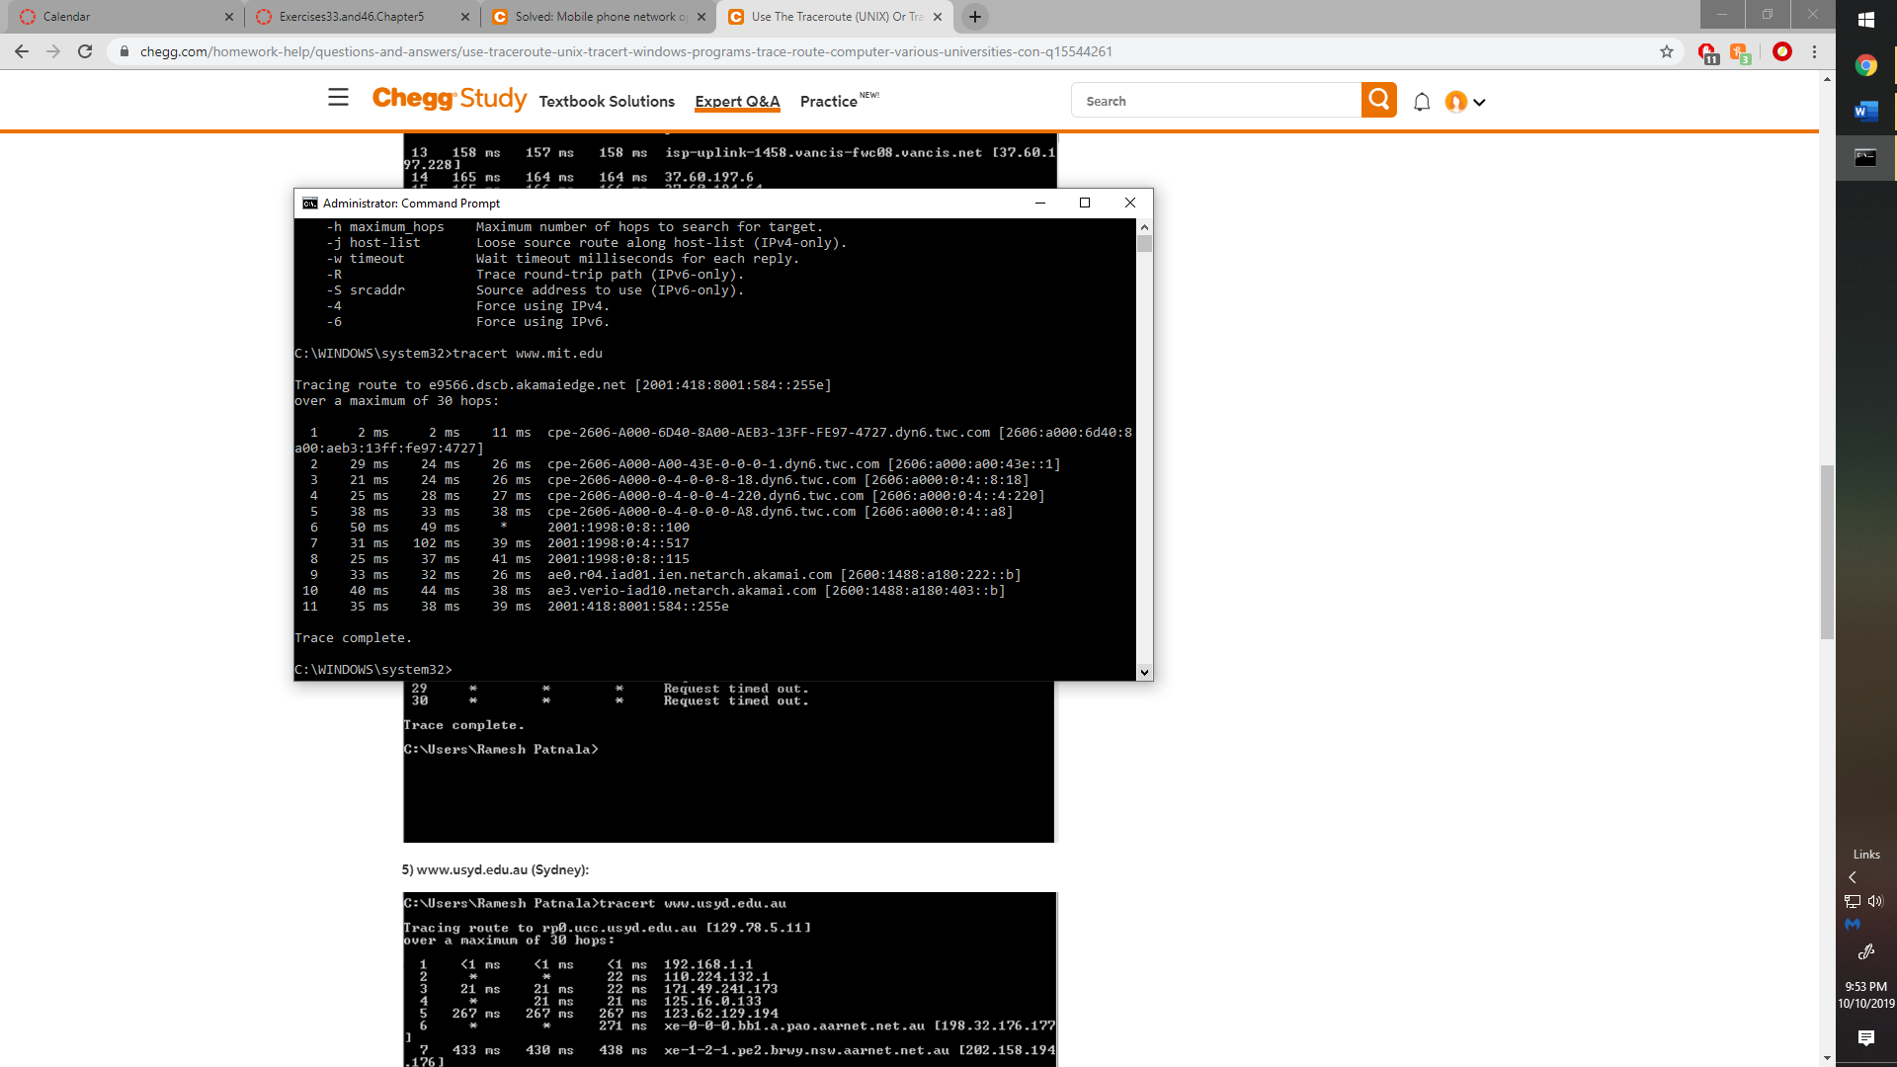

www.vu.nl (Amsterdam)

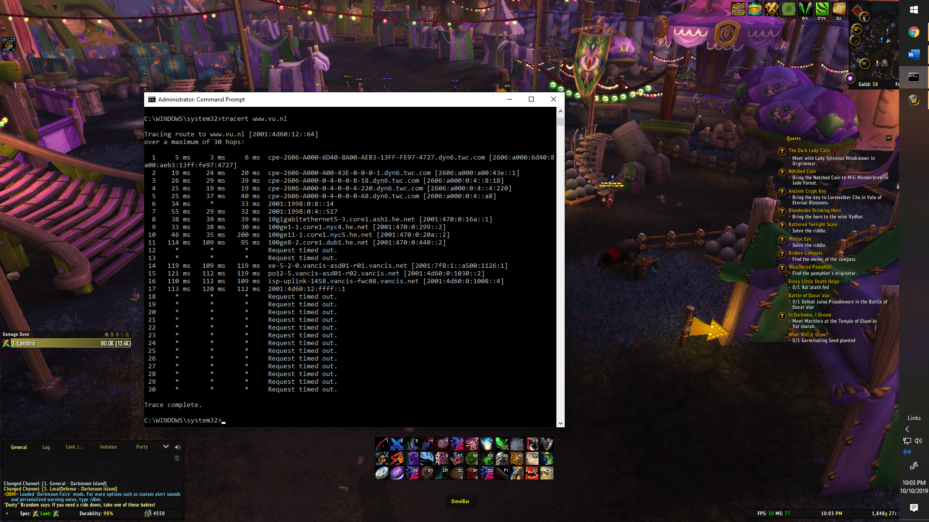

www.ucl.ac.uk (London)

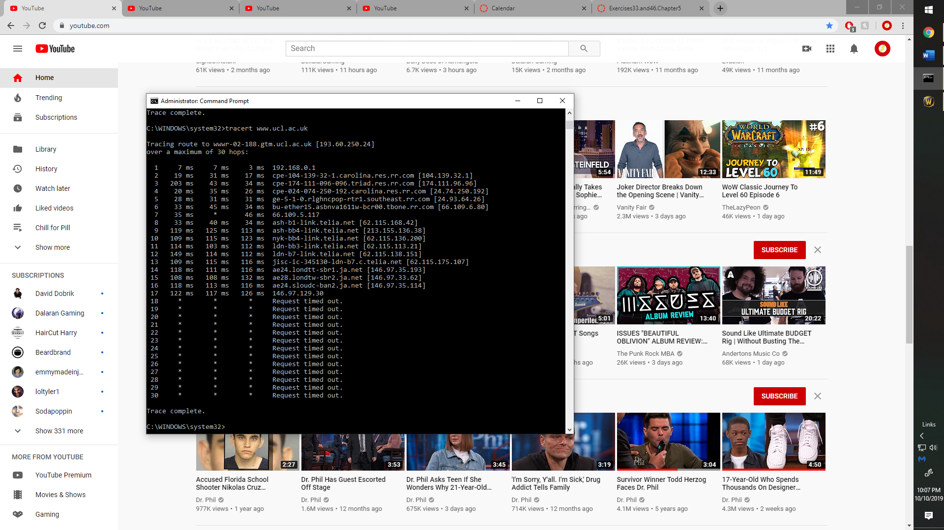

www.usyd.edu.au (Sydney)

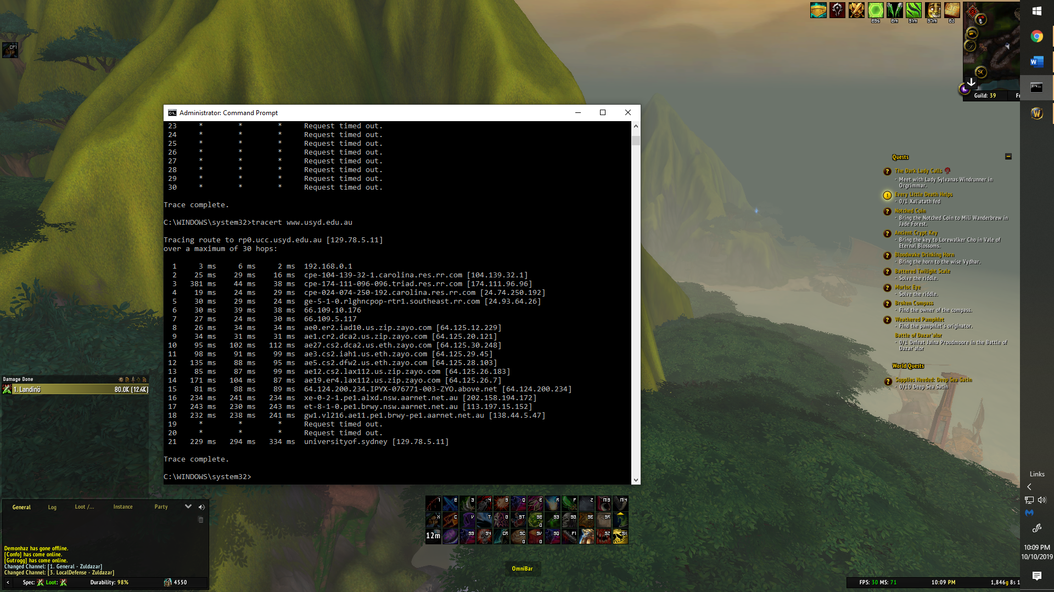

www.u-tokyo.ac.jp (Tokyo)

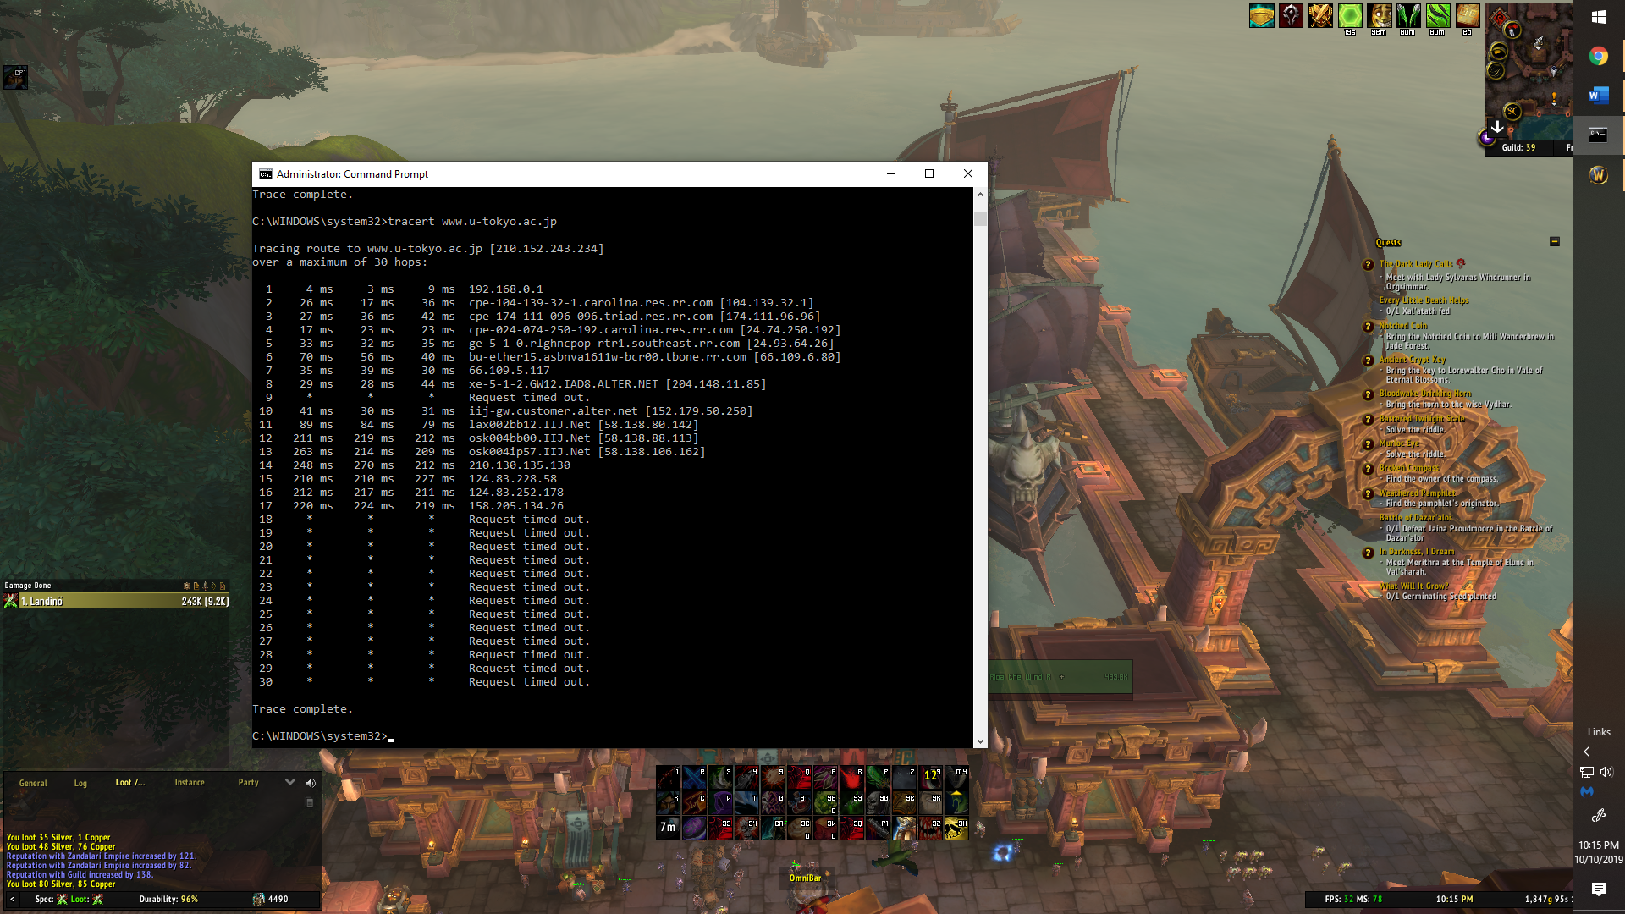

www.uct.ac.za (Cape Town)

